Bash_Scripting_2

1. Create on Bash script to check if a directory is available or not

* Make a subdirectory using 🡪 **mkdir -p / d1/d2**
* **Try to use that path using 🡪 cd /d2/d2**
* **Try to write create a file using 🡪 vi filename**
* **Try to give permission to that file using 🡪 chmod 777 filename**
* **Execute by using 🡪 ./filename.**

1. write a script to print Hello wrold 🡪

**#!/bin/bash**

**echo"Hello world”**

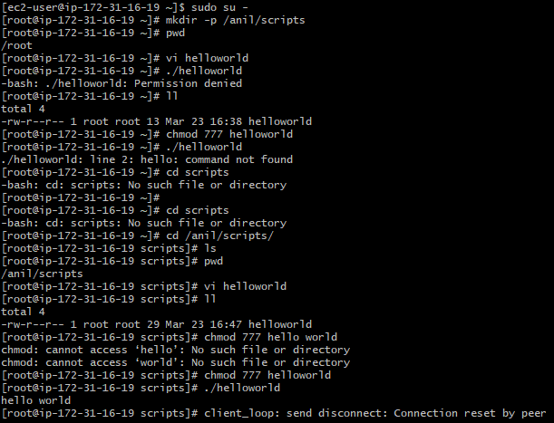

1. Create a bash script which will create multiple files.

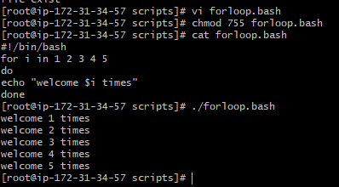

1. Create a bash script to take backup of a directory.

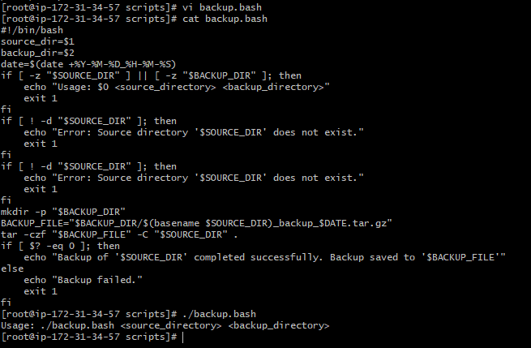

1. Create a bash script to install nginx in ec2 server.

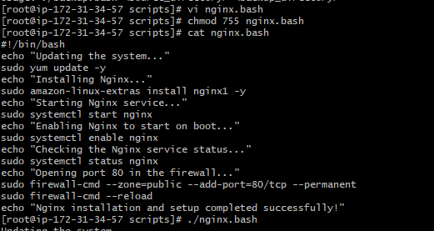

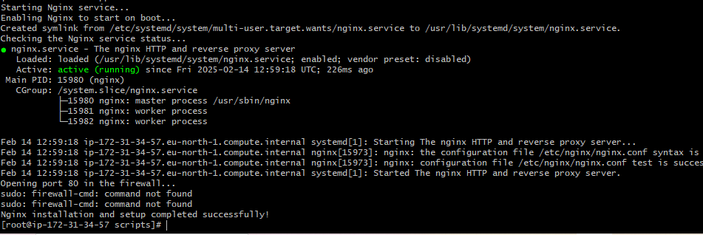

1. Create a bash script to install ApacheTomcat in ec2 server.

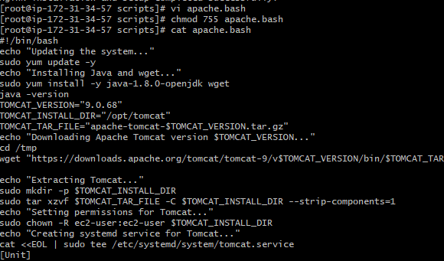

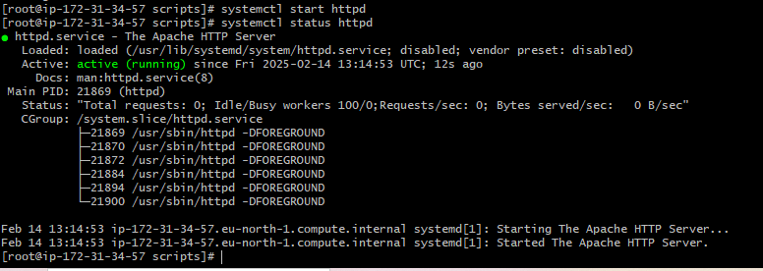

1. Create a bash script to check list if nginx service is running or not,if not running then script should start the service

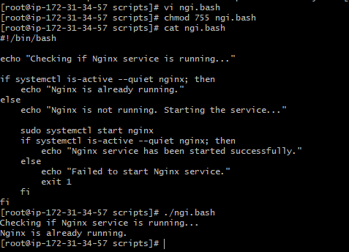

1. Create a bash script for calculator

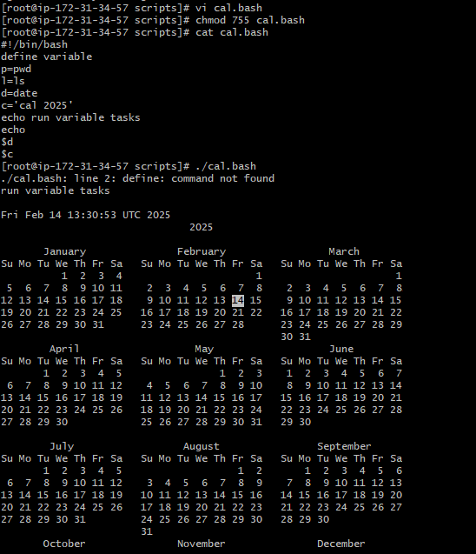

1. Create a bash script to check if directory is avaialble or not,if not then create a directory.

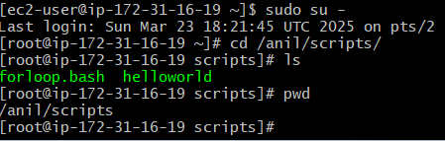

1. Create bash script to delete last 3 lines for a file

